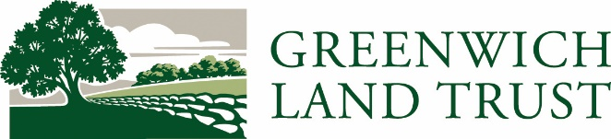
Contact: Sophie Neumann
Development & Communications Manager
sophie@gltrust.org
203-629-2152 ext. 102
Green Fingers, Greenwich Garden Club, and Hortulus Partner to Support Greenwich Land Trust’s Converse Brook Preserve
Greenwich Land Trust (GLT) is an organization founded on partnerships. Since its inception, GLT has worked with many local organizations and groups to accomplish its core objective of conserving open space while expanding upon the mission of connecting the community to the natural world and inspiring the next generation of conservationists.
In the late 1960s, members of Greenwich Garden Club led the charge to coordinate discussions with the Town of Greenwich and Greenwich Audubon Society to establish a local land holding organization.
In 1971, the Land Trust Division of Greenwich Audubon Society was formed, and Greenwich Garden Club donated $5,000 as a start-up contribution. After much success and enthusiasm, Greenwich Land Trust became its own entity in 1976.
Green Fingers Garden Club and Hortulus were also early champions of GLT. All three garden clubs have been engaged through annual giving and special projects over the years.
In 2015, GLT was in the midst of a capital campaign to restore the buildings on the newly donated 4-acre Mueller Preserve, which would become the hub of the organization with offices, a greenhouse, and barns for storing equipment and hosting educational programs and events. Each of the three garden clubs made generous contributions toward the native Kitty Starr and wetlands gardens and the habitat fountain on the preserve creating the ideal environment for pollinators.
Last year, the three clubs came together again to ensure GLT was able to complete one of its most important acquisitions yet. In September 2020, Greenwich Land Trust (GLT) acquired the 72.27-acre Converse Brook Preserve, at the corner of Lake Avenue and Old Mill Road from Aquarion Water Company. The vital piece of land remained untouched, yet unprotected, for generations, but is now GLT’s largest preserve and protected in perpetuity.
The acquisition was accomplished through a partnership between GLT and the Town of Greenwich with each equally contributing to the $2 million sale price. For GLT, the task of raising $1 million for the acquisition was a welcome challenge because of the enduring support from partners such as Green Fingers Garden Club, Greenwich Garden Club, and Hortulus.
The garden clubs are longstanding organizations with Greenwich Garden Club founded in 1914, Hortulus in 1930, and Green Fingers Garden Club in 1935. Their members have been indispensable role models, advisors, and confidants for GLT. They have been vital partners in caring for our natural resources that contribute to the historic character and scenic beauty of Greenwich.

